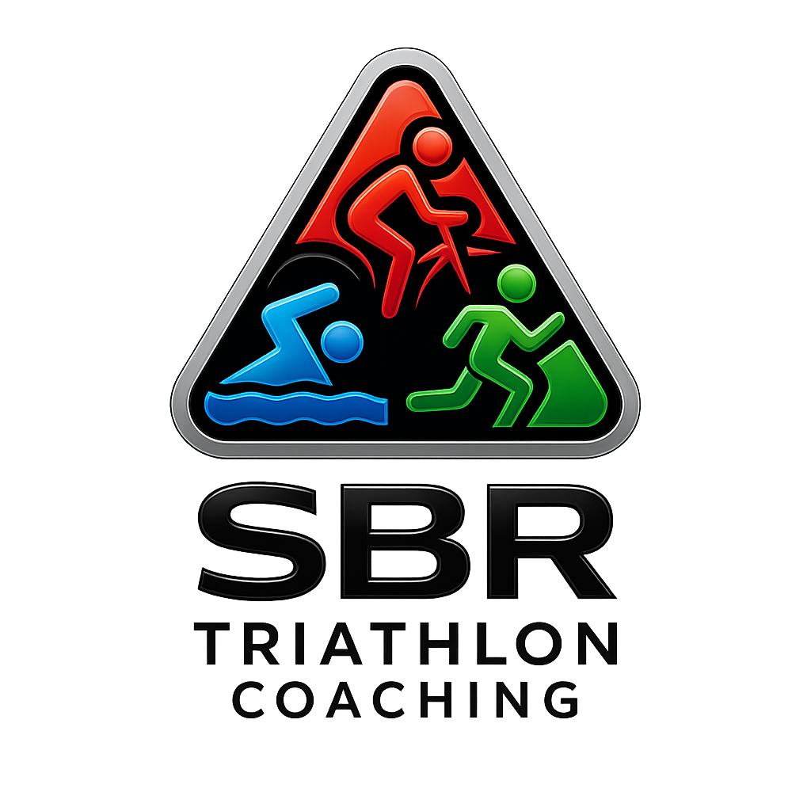


SBR Triathlon Coaching – Physical Activity Readiness Questionnaire (PAR-Q)
This Physical Activity Readiness Questionnaire (PAR-Q) helps identify potential health risks before starting or increasing physical activity. Please answer each question honestly by selecting YES or NO. If you answer YES to any question, you should consult your GP or a qualified medical professional before taking part in structured exercise or triathlon training.

Athlete Information
Athlete Name:
Date:
Address and post code:
Telephone (mobile) No.
Email:
Date of Birth:
Next of Kin:
Emergency Contact No.

Health Screening Questions
☐ YES ☐ NO Has your doctor ever said that you have a heart condition or that you should only do physical activity recommended by a doctor?
☐ YES ☐ NO Do you feel pain in your chest during physical activity?
☐ YES ☐ NO In the past month, have you had chest pain when you were not doing physical activity?
☐ YES ☐ NO Do you lose your balance because of dizziness, or do you ever lose consciousness?
☐ YES ☐ NO Do you have a bone, joint, or muscle problem that could be made worse by physical activity?
☐ YES ☐ NO Is your doctor currently prescribing medication for blood pressure or a heart condition?
☐ YES ☐ NO Do you know of any reason why you should not take part in physical activity or triathlon training?
☐ YES ☐ NO Do you currently have, or have you previously experienced, asthma, diabetes, or any chronic illness that may affect performance?
☐ YES ☐ NO Have you ever been advised by a medical professional not to participate in swimming, cycling, or running?
☐ YES ☐ NO Have you experienced fainting, dizziness, or shortness of breath during exercise?
☐ YES ☐ NO Do you have any injuries, ongoing pain, or musculoskeletal problems that may affect training or competition?
☐ YES ☐ NO Are you currently pregnant, or have you given birth in the last 6 months?
☐ YES ☐ NO Do you take any regular medication that may influence heart rate, blood pressure, or hydration status?
☐ YES ☐ NO Do you have any known allergies, including to insect stings or medications, that may require an emergency plan during training or competition?
☐ YES ☐ NO Do you smoke, vape, or regularly use nicotine products?
☐ YES ☐ NO Are you currently using, or have you recently used, GLP-1 receptor agonist medication (e.g., Ozempic, Wegovy, Mounjaro, Rybelsus)?
If yes, please note that these medications can affect such things as energy availability, and hydration, amongst others. This may affect your ability to conduct the sessions as prescribed within your training plan.

Important Notes
• If you answered NO to all questions, it is safe for you to begin physical activity gradually, building up intensity and duration based on your current fitness level.
• If you answered YES to one or more questions, consult your GP before taking part in structured training or competition.
• Stop exercising immediately and seek medical advice if you experience chest pain, dizziness, fainting, or unusual shortness of breath.

Declaration
I have read and understood this questionnaire. I confirm that my answers are accurate and complete to the best of my knowledge. I understand that I am responsible for monitoring my own condition during exercise and will stop if I feel unwell.

Athlete Signature: __________________________ Date: ____________________________



Coach/Witness Signature: ___________________ Date: ____________________________

